DEPARTMENT OF COMPUTER SCIENCE & ENGINEERING (AI & ML)

Heart Disease Prediction

A project report submitted to
MALLA REDDY UNIVERSITY
in partial fulfillment of the requirements for the award of degree of

BACHELOR OF TECHNOLGY
in
COMPUTER SCIENCE & ENGINEERING (AI & ML)

Submitted by

CH Varshith : 2111CS020620
H Varshith : 2111CS020621
D Varshitha : 2111CS020622
M Varshitha : 2111CS020623
T Varshitha : 2111CS020624
G Varun : 2111CS020625

Under the Guidance of

Komati satish
Asst.Professor

2023

COLLEGE CERTIFICATE

This is to certify that this is the bonafide record of the application development entitled,” HEART DISEASE PREDICTION” Submitted by CH Varshith(2111CS020620), H Varshith(2111CS020621), D Varshitha(2111CS020622), M Varshitha(2111CS020623), T Varshitha(2111CS020624), G Varun(2111CS020625), B. Tech II year II semester, Department of CSE (AI&ML) during the year 2022-23. The results embodied in the report have not been submitted to any other university or institute for the award of any degree or diploma.

PROJECT GUIDE HEAD OF THE DEPARTMENT

Prof. Komati sateesh Dr. Thayyaba Khatoon

CSE(AI&ML)

ACKNOWLEDGEMENT

We would like to take this opportunity to express my heartfelt gratitude to my Guide and Head of Department for their unwavering support, guidance, and encouragement throughout the development of this “Heart Disease Prediction”. Their expertise, valuable insights, and constructive feedback have been instrumental in shaping the project’s direction and ensuring its successful completion. Our sincere thanks to our guide, who have dedicated their time and effort to providing us with the necessary resources and knowledge to develop this project. Their constant motivation and assistance helped us overcome various challenges and ensured project’s timely completion. Additionally, We would like to thank the Head of Department for providing the necessary infrastructure and resources for the successful completion of this project. Once again, We extend our heartfelt appreciation and gratitude to all of them for their invaluable support and guidance.

CONTENTS

CHAPTER NO. | TITLE | PAGE NO.
1 | INTRODUCTION  - Abstract  1.3 Limitations of project | 6
2 | ANALYSIS  2.1Software requirement specification  2.1.1 Software requirement  2.1.2 Hardware requirement  2.2 Modules  2.3 Architecture | 7-10
3 | - DESIGN:  3.1 Data Set Descriptions  3.2 Methods & Algorithms  3.2 Building a Model | 11-15
4 | - DEPLOYMENT AND RESULTS  4.1 Source Code  4.2 Final Results
5 | CONCLUSION  5.1 Project conclusion  5.2 Future scope

1.INTRODUCTION

  - Introduction

Heart disease is a leading cause of mortality worldwide, and early detection and accurate prediction of heart disease risk are crucial for effective prevention and treatment. Machine learning and deep learning techniques have shown great promise in predicting heart disease based on patient data. However, one common challenge in developing accurate predictive models for heart disease is dealing with imbalanced data.

  - Abstract

Cardiovascular sickness is a major reason of dreariness and mortality in the present living style. Distinguishing proof of cardiovascular ailment is an imperative yet an intricate errand that should be performed minutely and proficiently and the right robotization would be exceptionally attractive. Each individual can't be equivalently skilled thus as specialists. All specialists can't be similarly talented in each sub claim to fame and at numerous spots we don't have gifted and authority specialists accessible effortlessly. A mechanized framework in therapeutic analysis would upgrade medicinal consideration and it can likewise lessen costs.

  - Limitations
- Incomplete data: The accuracy of heart disease prediction models relies heavily on the availability of comprehensive and high-quality data. Missing or inaccurate data can lead to flawed predictions.
- Data quality: The quality of the data used for prediction is crucial. Inaccurate or outdated data can lead to incorrect predictions. Garbage in, garbage out (GIGO) is a common problem in predictive modeling.
- Overfitting: Overfitting occurs when a model is too complex and fits the training data too closely. This can lead to poor generalization to new, unseen data, making predictions less reliable.
2.ANALYSIS

2.1 Software requirement specification
2.1.1 Software requirement
1.Programming Languages:
Python: Widely used for machine learning and data analysis.
R: Another language commonly used for statistical analysis and machine learning.
2. Machine Learning Libraries:
Scikit-learn: A powerful library for machine learning in Python, offering various algorithms for classification, regression, and model evaluation.
TensorFlow or PyTorch: Deep learning frameworks for creating neural networks.
XGBoost, LightGBM, or CatBoost: Libraries for gradient boosting algorithms, which can be helpful for predictive modeling.
3. Data Manipulation and Analysis:
Pandas: Python library for data manipulation and analysis.
NumPy: Fundamental package for numerical computations in Python.
matplotlib and Seaborn: Libraries for data visualization.
2.1.2 Hardware requirement
The hardware requirements to run a gym administration project created using python are modest, and most modern computers should be able to handle the project’s demands without issue.

- Minimum RAM required – 4GB RAM
- Display – Monitor
- Input devices – Keyboard, Mouse
- Sufficient Storage
2.2 Modules
- Upload Training data:
The process of rule generation advances in two stages. During the first stage, the SVM model is built using training data During each fold, this model is utilized for predicting the class labels The rules are evaluated on the remaining 10% of test data for determining the accuracy, precision, recall and F-measure. In addition, rule set size and mean rule length are also calculated for each fold of cross-validation
- Data pre processing:
The dataset contains a total of 303 patient records, where 6 records are with some missing values. Those 6 records have been removed from the dataset and the remaining 297 patient records are used in pre-processing. The multiclass variable and binary classification are introduced for the attributes of the given dataset.
- Predicting heart disease:
Many factors, such as diabetes, high blood pressure, high cholesterol, and abnormal pulse rate, need to be considered when predicting heart disease [11]. Often, the medical data available need to be completed, affecting the results in predicting heart disease. Machine learning plays a crucial role in the medical field.
- Graphical representation:
A graphical representation is a visual representation of data statistics-based results using graphs, plots, and charts. This kind of representation is more effective in understanding and comparing data than seen in a tabular form.

2.3 Architecture

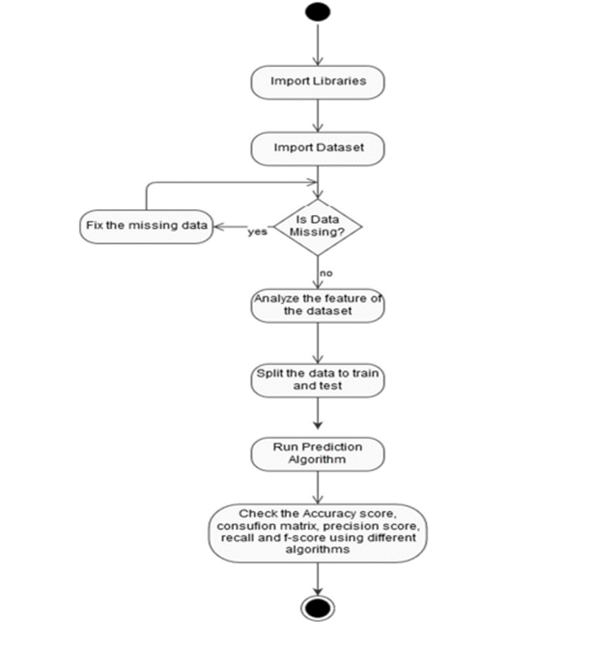

3.DESIGN
3.1 Data Set Descriptions

The "Effect of Imbalance Data Handling Techniques to Improve the Accuracy of Heart Disease Prediction using Machine Learning and Deep Learning" dataset encapsulates a comprehensive array of fields crucial for understanding and predicting heart health. It includes demographic information such as age, gender, ethnicity, and socioeconomic status, alongside clinical metrics like blood pressure, cholesterol levels, BMI, and diabetes status. Lifestyle factors, including smoking habits, physical activity levels, and dietary patterns, contribute to a holistic representation of an individual's health profile.
One such system is the Heart Disease Prediction System (HDPS), which
uses Naïve Bayes and Decision Tree algorithms for predicting the risk level of heart disease. The system uses 15 medical parameters such as age, sex, blood pressure, cholesterol, and obesity for prediction. The HDPS predicts the likelihood of patients getting heart disease 2.

- Demographic Information:
  - Age (numerical)
  - Gender (categorical: male, female)
  - Ethnicity (categorical: various ethnic groups)
- Clinical Metrics:
  - Systolic Blood Pressure (numerical)
  - Diastolic Blood Pressure (numerical)
  - Cholesterol Levels (numerical)
  - Presence of Diabetes (binary: yes, no)
- Lifestyle Factors:
  - Smoking Habits (categorical: smoker, non-smoker, former smoker)
  - Physical Activity Levels (categorical: sedentary, moderate, active)
  - Dietary Patterns (categorical: healthy, balanced, unhealthy)

- Medical History:
  - Family History of Heart Disease (binary: yes, no)
  - Previous Heart-Related Incidents (binary: yes, no)
3.2 Model & Algorithms
There are several models and algorithms that can be used in a gym administration system. Here are some examples:
- Logistic Regression
Logistic regression is a classification algorithm used to assign observations to a discrete set of classes. Unlike linear regression which outputs continuous number values, logistic regression transforms its output using the logistic sigmoid function to return a probability value which can then be mapped to two or more discrete classes.
Type of Logistic Regression:
Binomial: In binomial Logistic regression, there can be only two possible types of the dependent variables, such as 0 or 1, Pass or Fail, etc.

Multinomial: In multinomial Logistic regression, there can be 3 or more possible unordered types of the dependent variable, such as “cat”, “dogs”, or “sheep”

Ordinal: In ordinal Logistic regression, there can be 3 or more possible ordered types of dependent variables, such as “low”, “Medium”, or “High”.

- Random Forest
Random Forest is a supervised learning algorithm. Random forest can be used for both classification and regression problems, by using random forest regressor we can use random forest on regression problems. But we have used random forest on classification in this project so we will only consider the classification part .
Random Forest is a classifier that contains a number of decision trees on various subsets of the given dataset and takes the average to improve the predictive accuracy of that dataset 1. Instead of relying on one decision tree, the random forest takes the prediction from each tree and based on the majority votes of predictions, and it predicts the final output 1. The greater number of trees in the forest leads to higher accuracy and prevents the problem of overfitting.

- Naïve Bayes
Naive Bayes is a classification algorithm for binary (two-class) and multi-class classification problems. The technique is easiest to understand when described using binary or categorical input values. It is called naive Bayes or idiot Bayes because the calculation of the probabilities for each hypothesis are simplified to make their calculation tractable. It is mainly used in text classification that includes a high-dimensional training dataset.
Naïve Bayes Classifier is one of the simple and most effective Classification algorithms which helps in building the fast machine learning models that can make quick predictions.

- K-Nearest Neighbour
K-Nearest Neighbour is one of the simplest Machine Learning algorithms based on Supervised Learning technique.
We can implement a KNN model by following the below steps:
1. Load the data
2. Initialize the value of k
3. For getting the predicted class, iterate from 1 to total number of training point.

- Decision Tree
Decision Tree is a Supervised learning technique that can be used for both classification and Regression problems, but mostly it is preferred for solving Classification problems
1. Place the best attribute of the dataset at the root of the tree.
2. Split the training set into subsets. Subsets should be made in such a way that each subset contains data with the same value for an attribute.
3. Repeat step 1 and step 2 on each subset until you find leaf nodes in all the branches of the tree.

3.3 Building a model
Identify the requirements: Before building the model, it is essential to understand the requirements of the heart disease predicton. This includes identifying the features and functionalities that the system should have, such as member registration, scheduling classes, managing staff, tracking inventory, and processing payments.

Design the data model: Once the requirements are identified, the next step is to design the data model. This involves creating a schema or blueprint of the database that will store all the relevant information. The data model should be designed in a way that allows for efficient querying and retrieval of data.

Develop the user interface: The user interface is the front-end of the gym administration system that users interact with. It should be designed to be intuitive, user-friendly, and visually appealing. The user interface should provide access to all the features and functionalities of the system.

Implement the backend: The backend is the part of the system that processes user requests and manages data storage and retrieval. This involves developing the server-side code and integrating it with the database.

Test and deploy: Once the Heart disease prediction is built, it should be thoroughly tested to ensure that it is working as expected. Any bugs or issues should be identified and fixed before deployment. The system can then be deployed on the production server, and users can start using it.

Maintain and update: After deployment, it is important to maintain and update the system regularly. This includes fixing any bugs, adding new features, and ensuring that the system is secure and up-to-date with the latest technologies.

DEPLOYMENT AND RESULTS
4.1 Source Code
import numpy as np
import pandas as pd
import matplotlib.pyplot as plt
import seaborn as sns
%matplotlib inline
import os
print(os.listdir())
import warnings
warnings.filterwarnings('ignore')
dataset = pd.read_csv("heart.csv")
dataset.info()
y = dataset["target"]
sns.countplot(y)
target_temp = dataset.target.value_counts()
print(target_temp)
sns.barplot(dataset["sex"],y)
sns.barplot(dataset["cp"],y)
dataset["ca"].unique()
sns.countplot(dataset["ca"])
sns.barplot(dataset["ca"],y)
from sklearn.model_selection import train_test_split
predictors = dataset.drop("target",axis=1)
target = dataset["target"]
X_train,X_test,Y_train,Y_test = train_test_split(predictors,target,test_size=0.20,random_state=0)
from sklearn.linear_model import LogisticRegression
lr = LogisticRegression()
lr.fit(X_train,Y_train)
Y_pred_lr = lr.predict(X_test)
score_lr = round(accuracy_score(Y_pred_lr,Y_test)*100,2)
print("The accuracy score achieved using Logistic Regression is: "+str(score_lr)+" %")
from sklearn.naive_bayes import GaussianNB
nb = GaussianNB()
nb.fit(X_train,Y_train)

Y_pred_nb = nb.predict(X_test)
from sklearn.neighbors import KNeighborsClassifier
knn = KNeighborsClassifier(n_neighbors=7)
knn.fit(X_train,Y_train)
Y_pred_knn=knn.predict(X_test)
from sklearn.tree import DecisionTreeClassifier
max_accuracy = 0
for x in range(200):
dt = DecisionTreeClassifier(random_state=x)
dt.fit(X_train,Y_train)
Y_pred_dt = dt.predict(X_test)
current_accuracy = round(accuracy_score(Y_pred_dt,Y_test)*100,2)
if(current_accuracy>max_accuracy):
max_accuracy = current_accuracy
best_x = x
dt = DecisionTreeClassifier(random_state=best_x)
dt.fit(X_train,Y_train)
Y_pred_dt = dt.predict(X_test)
from sklearn.ensemble import RandomForestClassifier
max_accuracy = 0
for x in range(2000):
rf = RandomForestClassifier(random_state=x)
rf.fit(X_train,Y_train)
Y_pred_rf = rf.predict(X_test)
current_accuracy = round(accuracy_score(Y_pred_rf,Y_test)*100,2)
if(current_accuracy>max_accuracy):
max_accuracy = current_accuracy
best_x = x
rf = RandomForestClassifier(random_state=best_x)
rf.fit(X_train,Y_train)
Y_pred_rf = rf.predict(X_test)

4.2 Final Results

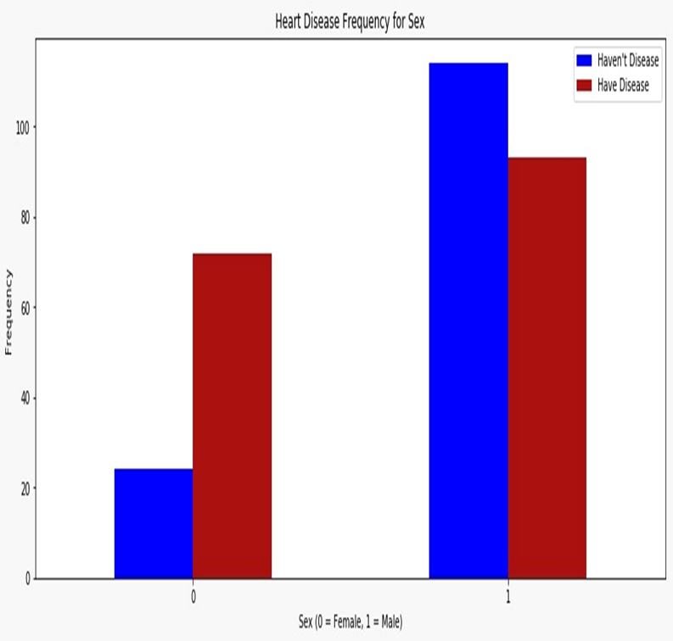

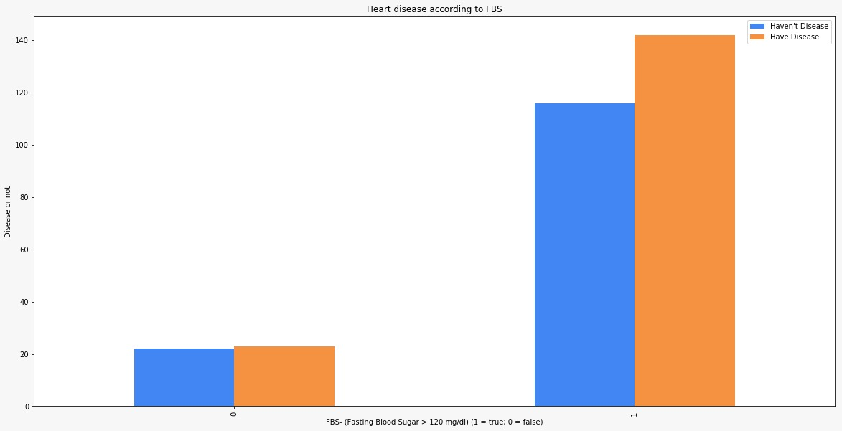
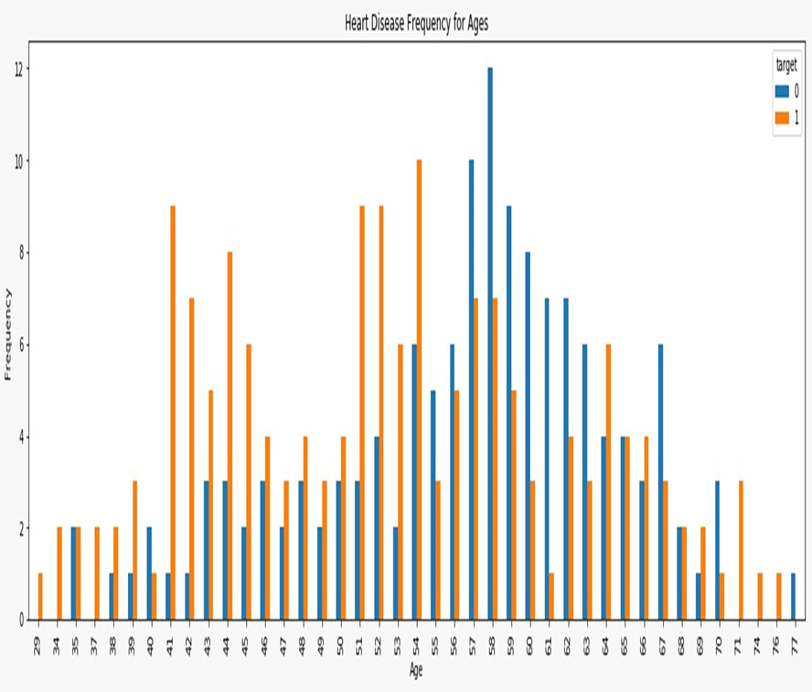

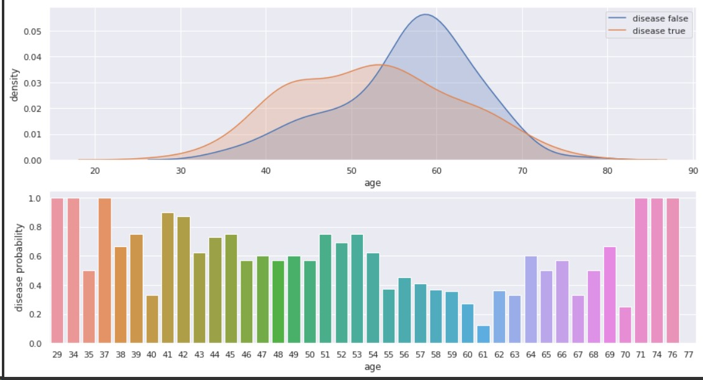

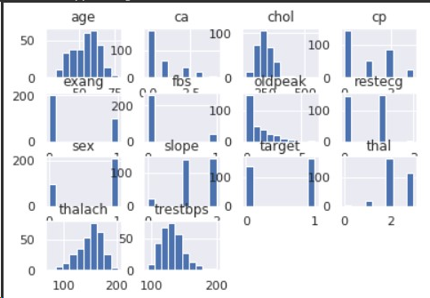

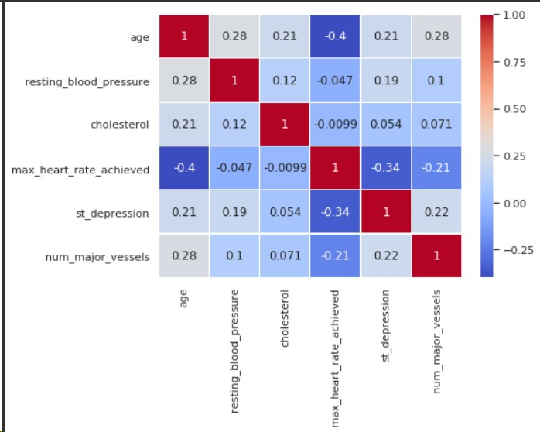

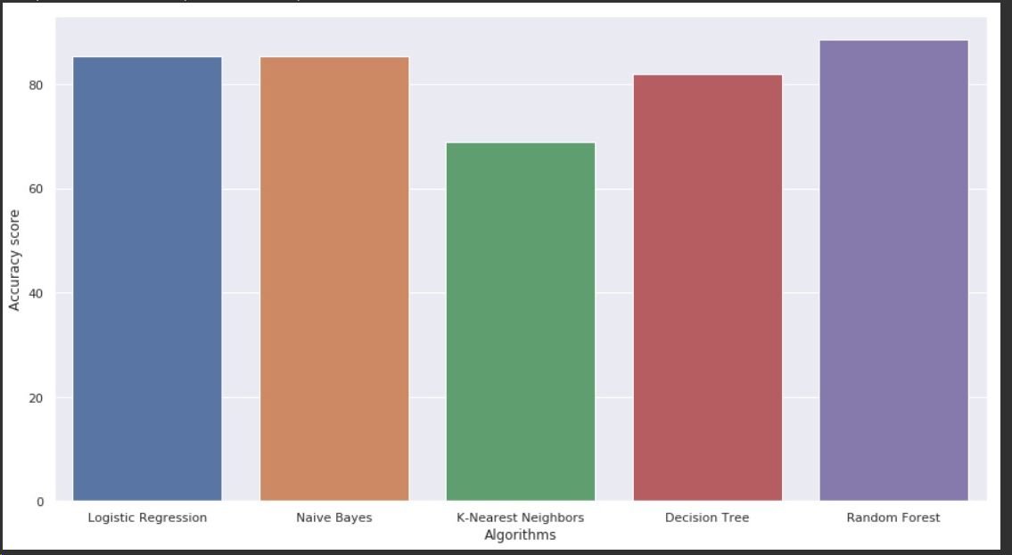

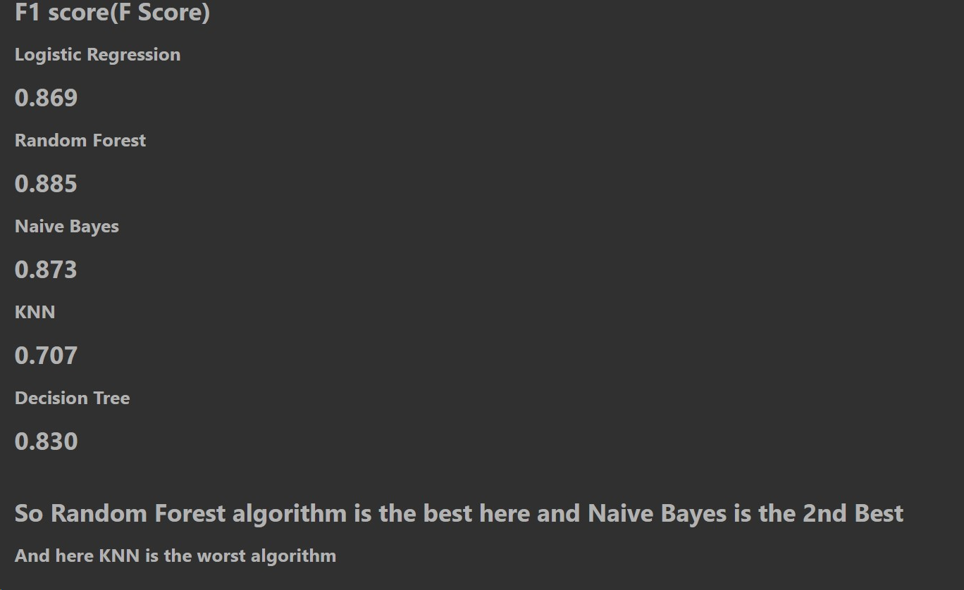

5.CONCLUSION
5.1 Project conclusion
The overall objective of our project is to predict accurately with less number of tests and attributes the presence of heart disease. In this project, fourteen attributes are considered which form the primary basis for tests and give accurate results more or less. Many more input attributes can be taken but our goal is to predict with less number of attributes and faster efficiency to predict the risk of having heart disease at a particular age span. Five data mining classification techniques were applied namely K-Nearest Neighbor, Naive Bayes, Decision Tree, Random Forest & Logistic Regression. It is shown that Random Forest has better accuracy than the other techniques.
This is the most effective model to predict patients with heart disease. This project could answer complex queries, each with its own strength with respect to ease of model interpretation, access to detailed information and accuracy. This project can be further enhanced and expanded. For example, it can incorporate other medical attributes besides the 14 attributes we used. It can also incorporate other data mining techniques, e.g., Time Series, Clustering and Association Rules. Continuous data can also be used instead of just categorical data. Another area is to use Text Mining to mine the vast amount of unstructured data available.

5.2 Future Scope
We are planning to introduce an efficient disease prediction system to predict the heart disease with better accuracy using Support Vector Machine (SVM). Our project aims to provide a web platform to predict the occurrences of disease based on various symptoms. The user can select various symptoms and can find the diseases with their probabilistic figures. Our project can be improved by implementing medicine suggestion to the patient along with the results. We can implement a feedback from the experienced doctors who can give their views and opinions about certain medicines /practices done by the doctor on the patient. We can implement a live chat option where the patient can chat with a doctor available regarding medication for the respective result for their symptoms. Our project could be used as a training tool for Nurses and Doctors who are freshly introduced in the field related to heart diseases

